**OSP - Portable System**

**Hardware Guide**

1. Introduction
2. Changes on DragonBoard 410c
3. Mezzanine Board
4. Analog BTE-RICs
5. Case

Written by Cagri Yalcin and THE_Lab team

1. **Introduction**

We developed a portable system with a DragonBoard 410c single board computer, custom-made analog BTE-RICs, and a custom-made mezzanine board which provides analog interface circuitry for the audio and a charging circuit for the rechargeable Li-Ion battery.

1. **Changes on DragonBoard 410c**

Three hardware changes need to be made on the DragonBoard 410c:

1. Desolder and remove power jack J1.
   * The mezzanine board provides a substitute power jack that accepts the same DC power supply, but which can charge the battery as well as supplying the DragonBoard.
2. Populate J7 with a 16-pin header (Digi-Key Part Number A115164-ND)
   * This header brings the audio signals to the mezzanine board.  
     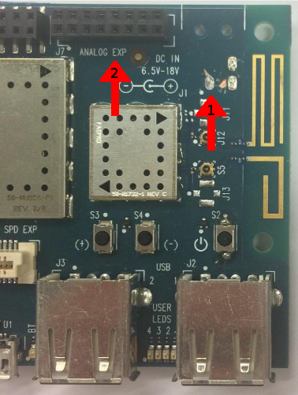  
     *Figure 1: Changes 1 and 2 on DragonBoard*
3. Solder a wire between pin 4 on GM1 (MIC1) and pin 16 on J7.
   * The PM8916 has three audio inputs: MIC1, MIC2, and MIC3. MIC1 is connected to GM1 on the DragonBoard, while MIC2 and MIC3 are brought to J7. However, these three inputs are not all identical: the PM8916 only has two audio ADCs, one of which is hardwired to the MIC1 input, and the other is switchable between the MIC2 and MIC3 inputs. So, we can’t use MIC2 and MIC3--the signals available on J7--for the left and right mics, because they can’t be used at the same time. Instead, we use MIC1 and MIC3, which means the MIC1 signal has to be connected to the mezzanine board somehow. Fortunately, pin 16 of J7 is not connected on the DragonBoard, so we have routed MIC1 to it on the mezzanine; all that remains is for the user to wire the DragonBoard side of this pin to the actual MIC1 signal on GM1.

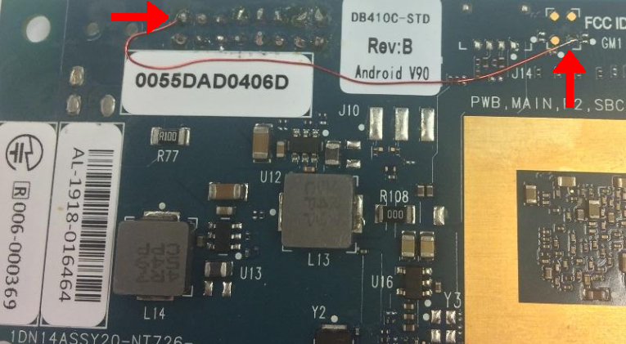

*Figure 2: Change 3 on DragonBoard*

1. **Mezzanine Board**

We designed a mezzanine board which goes on top of the DragonBoard, to provide two functions: first, to provide a differential interface with the BTE-RICs, and second, to charge the Li-Ion battery.

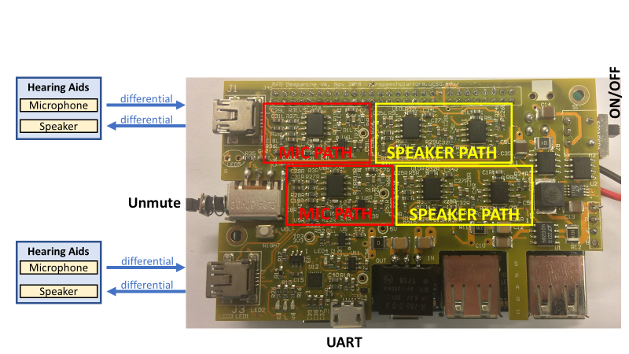

*Figure 3: Mezzanine Board*

To reduce the noise in the analog audio path due to transmission over the cable (~1 meter), we are using differential signaling in both directions from the BTE-RICs to the portable system.

A differential input comes into the mezzanine from the BTE-RICs; the mezzanine brings it down to the correct levels to fit it into the input range of the ADC on the DragonBoard. During characterization of the input level of the ADC, we saw that when the signal hits its top and bottom rails, this causes leakage from that channel to the other channel on the digital side; so we designed the microphone input circuit that it could never hit the rail, even if there is clipping earlier in the signal chain.

We also ensured that we use the entire dynamic range (0 - 2.7V) which is possible for the ADC. The onboard bias (1.8V) would prevent us from achieving the entire dynamic range because it is 0.45V higher than the actual middle of the range (1.35V), so we made a decision to bias it correctly to get a better range. Despite to increasing the complexity, this provides a 2.5 Vpp signal range with a 0.1V buffer from the top and bottom rail.

For the receiver path, the signal comes out of the DAC and is first amplified; then it is made differential, and this signal directly drives the receivers in the BTE-RICs. We characterized the output based on the receiver which we are using in our hearing aids with the highest output performance to maximize the driving power.

With any open-loop hearing aid, there is a risk of hearing damage if problems occur at fitting and the hearing aid squeals or produces other loud noises directly into the ear canal. To mitigate this problem, we added a hardware unmute button onto the mezzanine board which cuts off the receiver signals. Additional to that, the mezzanine has a ON/OFF switch and a USB UART port for debugging the DragonBoard. The battery is charged to 8.4V at 0.75A (6.3W) and has a 23Wh (3200mAh) capacity. The system can operate about 15 hours on a single charge. Battery: https://www.batteryspace.com/custom-polymer-li-ion-battery-7-4v-3-2ah-23-68wh-battery.aspx

1. **BTE-RICs**

The BTE-RICs (behind-the-ear receiver-in-canal form factor units) for each ear contain the microphone and receiver and are wired to the portable unit. The cable itself is a ~1 meter 6-wire Mogami cable, and a Mini-USB B connector is provided on the other end which plugs into the mezzanine board for each channel. (The cable and connector carry analog signals; the USB connector was chosen for ruggedness and availability, but the signals are NOT USB. So please do not plug the BTE-RICs into a USB port on another system or any other device into the Mini-USB ports on the mezzanine.)

The BTE-RICs’ shell is a custom 3D printed design, with a strain relief system commonly implemented in commercial electronic devices. This strain relief ensure little movement at the wire-to-board connection point and prevents it from getting pinched near the inlet to the device case. Polyurethane casting was utilized for this due to its low barrier to entry and quick iterative process. Molds were created that allow the polyurethane strain relief to be molded directly to the PCB allowing for a strong bond without additional adhesives.

The BTE-RIC’s own circuitry contains a high-pass filter (160 Hz) for the microphone signal, which is then pre-amplified and converted to differential.

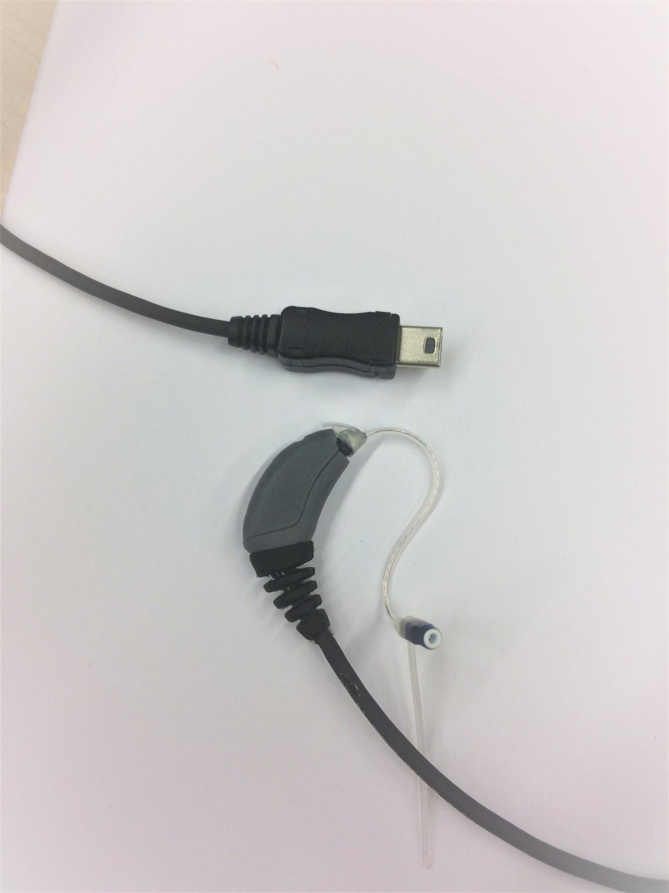

*Figure 4: BTE-RIC with Receiver and Mini-USB Connector*

1. **Case**

The DragonBoard, mezzanine board, and battery are mounted in a 3D printed case which can be worn around the neck for lab and field usage.

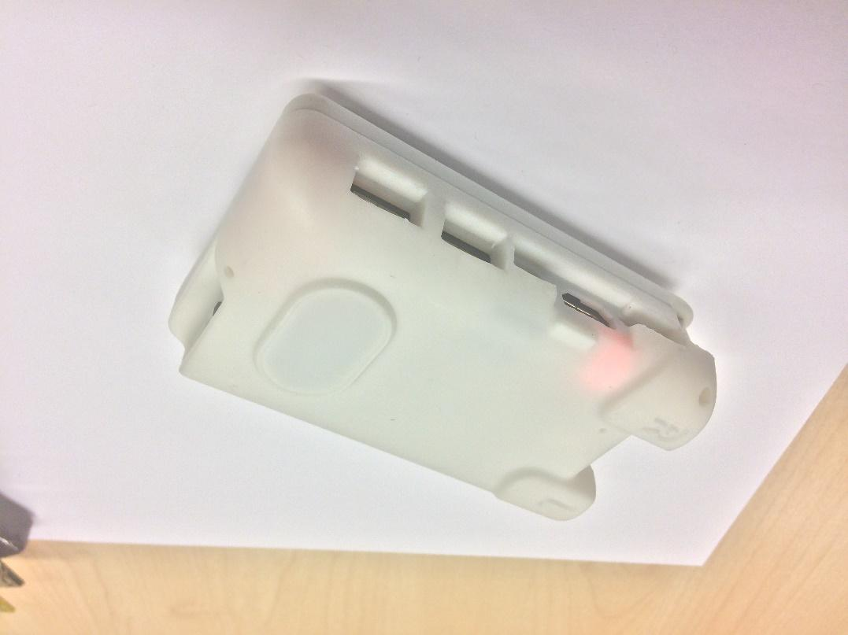

*Figure 5: Portable System*